4.2 Project: Database Interactions
Christopher Crayton
ECPI University
SDC330L: Advanced Object-oriented Programming Using Java LAB
Dr. Helio de Castro
August 23, 2026

4.2 Project: Database Interactions
Backend Design
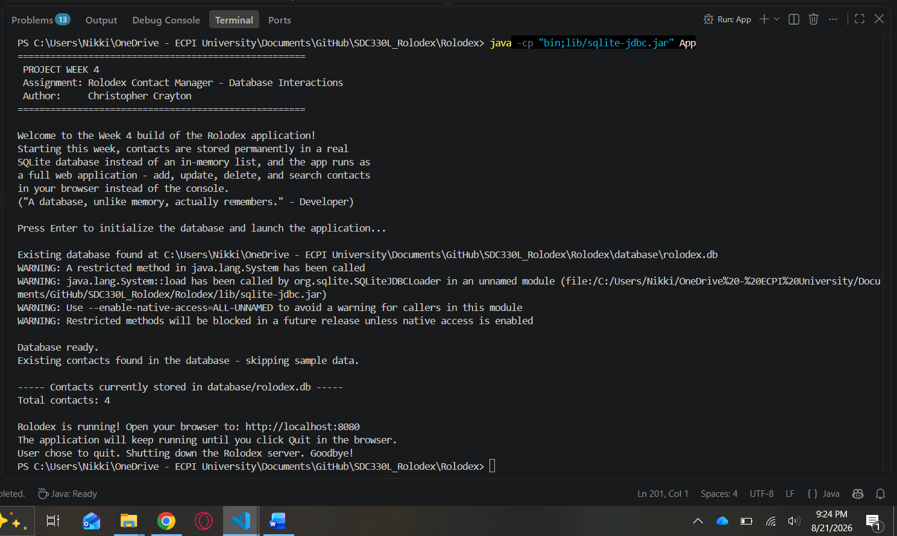
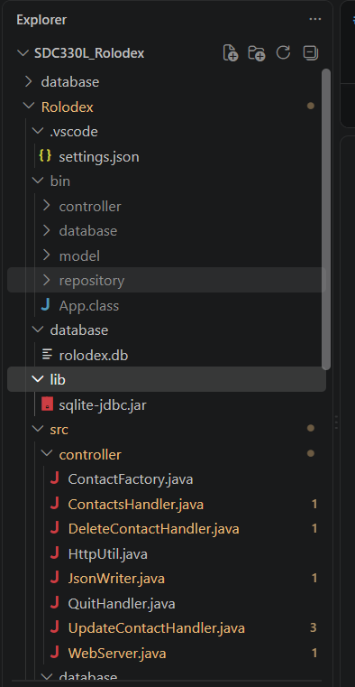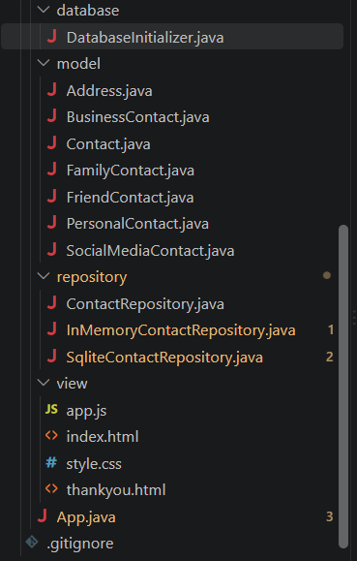

GUI Design
